INAMIGOS FOUNDATION
NGO Website Feature Highlight & UX Architecture Spec
Internship Task 4 • Figma UI/UX Design & Feature Architecture Document
Author: Neeli Sai Hakesh | Organization: InAmigos Foundation (Section 8 Non-Profit)
--------------------------------------------------------------------------------

1. Executive Summary & Objective
This document presents a high-fidelity UI/UX design architecture and feature specification tailored specifically for the InAmigos Foundation (https://inamigosfoundation.org.in). To elevate the foundation's digital presence to modern international non-profit standards, 5 mission-critical features have been identified, designed, and prototyped in a Figma-style design system. These features directly address donor drop-off, volunteer onboarding friction, and audit transparency.

2. Five Essential Features for InAmigos Foundation
Feature Name | Domain | Core Functionality & Impact
Feature 01: Instant Transparent 80G Donation & Impact Engine | Financial & Trust | Direct monetary-to-outcome mapping (e.g. ₹1,200 = 1 mo child education), one-time/monthly toggle, real-time 80G tax benefit preview, and automated WhatsApp/email 80G receipt generation.
Feature 02: Interactive Volunteer Skill-Matching & Fast-Track Portal | Talent & Operations | 3-step self-serve onboarding widget matching student/professional skills (Content, Design, Social Media, Field Rescue) to specific cohorts with instant WhatsApp induction links.
Feature 03: Live Geospatial Impact Dashboard & Transparency Telemetry | Audit & CSR Credibility | Interactive state map across 28 states, real-time animated counters (50k+ lives, 12.5k+ trees, 200+ volunteers), and 1-click downloads for audited Form 10B and CSR-1 compliance filings.
Feature 04: Verified Beneficiary Story Carousel with Direct Action Links | Empathy & Conversion | Human-centered narratives (Pooja's education journey, rescued animals) featuring authentic quotes, photos, location tags, and 1-click prepopulated 'Support This Child/Cause' buttons.
Feature 05: Goal-Driven Urgent Campaign Hub with Micro-Update Feeds | Crowdfunding & Urgency | Time-sensitive appeal cards (Mission Sheetla Winter Blanket Drive) with live progress bars, donor count, hours remaining, live field photo logs, and viral 1-click WhatsApp share buttons.

3. High-Fidelity UI Design & Mockups
Figure 1: Figma UI Architecture Overview & Design Tokens
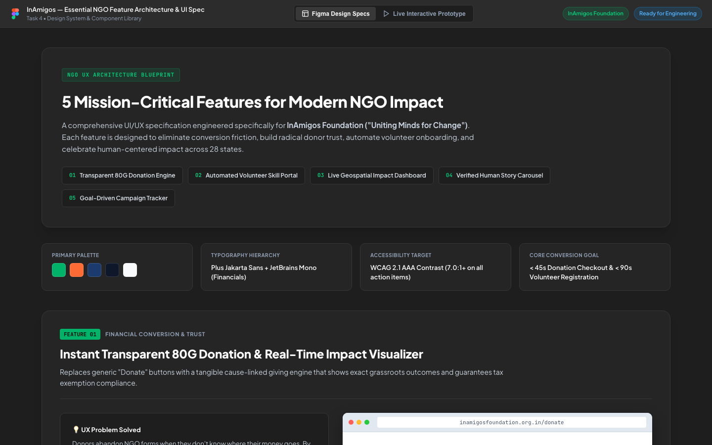
Figure 2: Component Layout & Tablet Responsive Design
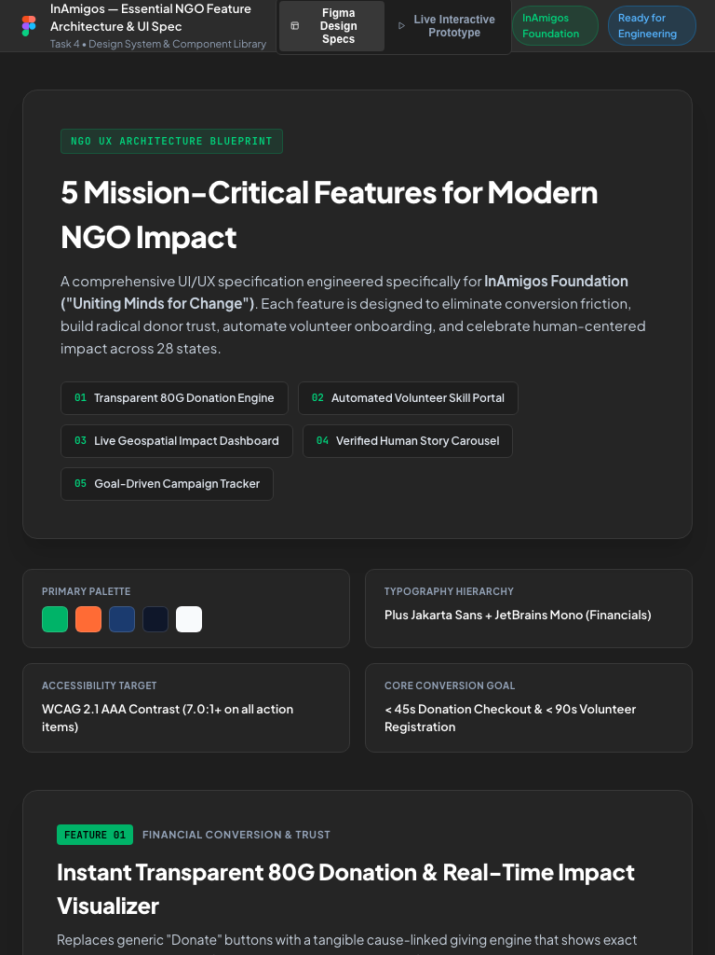

4. Technical Implementation Roadmap
Phase 1 (Week 1-2): Razorpay Payment Pages API integration + automated 80G tax receipt dispatch via webhooks.
Phase 2 (Week 3-4): Interactive multi-step volunteer skill-matching widget connected to Supabase/Airtable.
Phase 3 (Week 5-6): D3.js interactive impact map & dynamic crowdfunding progress engine.

